Problems of colonial life in Australia
- Match the aspects of life in the colonies with the related problems (or barriers to progress) that emerged.
Aspects of life in the colonies |  | Problems or barriers to progress
Chinese people and South Sea Islanders arrived to work on the goldfields and cane farms, often for lower pay than other colonists. |  | Rivalry and mistrust between some colonies, as the wealthier colonies thought they deserved more power.
Some colonies were very wealthy due to sheep farming and the discovery of gold. |  | Communication between the colonial governments and the British Government was often slow and complex.
Britain removed its military forces from Australia when convict transportation ended. |  | Some goods were expensive and hard to get, and trade between colonies was difficult.
Britain could overrule laws passed in the colonies and make laws for the colonies. |  | When they couldn’t find work, colonists became jealous of and angry at migrants.
Rail gauges in each colony were different. |  | Each colony became responsible for its own army, which was expensive, and there was no navy to protect the coastline.
Some colonies charged tariffs on goods arriving from other colonies. |  | Transport was slow by rail because people and supplies had to change trains at the borders.
- Read this cause and effect flow chart which explains the increase in population in Victoria during the 1850s.
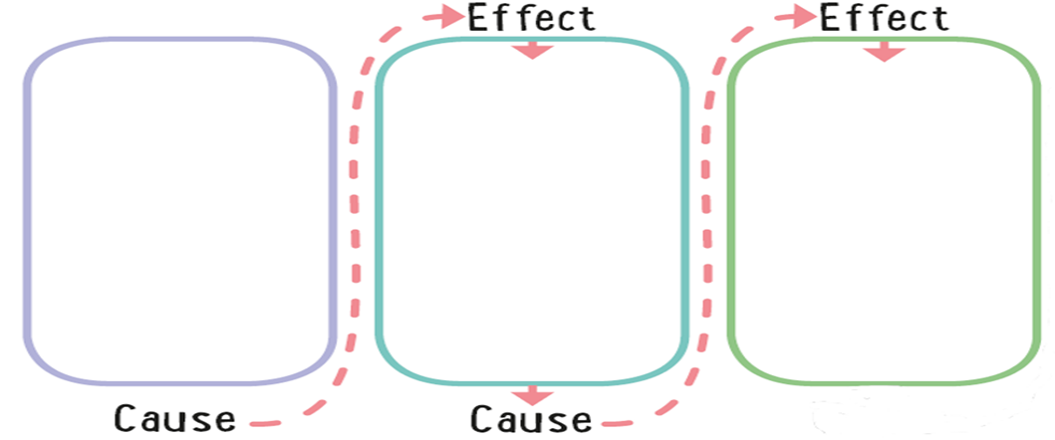
People moved to Victoria to work on the goldfields.
There was a rapid increase and change in the population of Victoria.
Gold was discovered in Victoria in 1851.
- Complete the cause and effect flow charts to show how three significant events that occurred in Australia during the 1800s supported the move towards Federation. Select the correct event or development from the box provided to insert into the spaces in the flow charts.
Event or development
A. People and goods had to change trains at colonial borders.
B. Each of the colonies formed its own army but there was no navy to protect the coastline.
C. People started thinking about Federation, which would mean Australia could adopt a single rail gauge, therefore making journeys by rail less complicated.
D. People started thinking about Federation, which would mean Australia could control the flow of migrants into the country.

Colonists were angry at migrants because they thought migrants were taking their jobs. They wanted them gone.
Chinese and South Sea Islander migrants arrived to work on goldfields and cane farms, often for lower pay than other colonists.

People started thinking about Federation because Australia needed a national defence force.
Britain removed its military forces from Australia when convict transportation ended.


Rail gauges in each colony were different.

